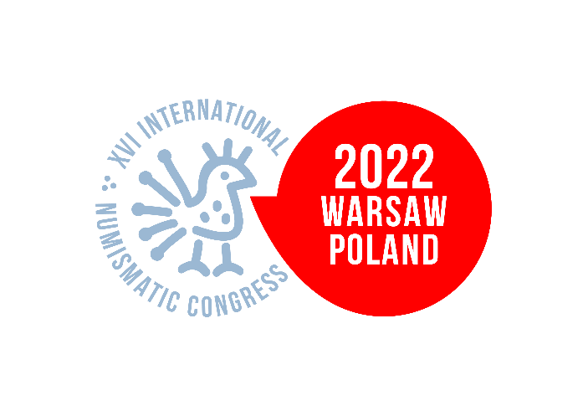
APPLICATION FORM

Travel grant for Georgian numismatist
founded by Warsaw Numismatic Center

Title: (prof. dr, Mr, Mrs etc.) | Title
First Name: | First Name
Last Name: | Last Name
Institution/affiliation: | Institution/affiliation
City: | City
E-mail: | E-mail
Phone: | +995
Scan of valid Georgian passport: | Please send the scan in separate attachment.
Language proficiency level (any from English, French, German, Italian or Spanish): A1 (beginner), A2 (elementary), B1 (intermediate), B2 (upper-inermediate), C1 (advanced), C2 (proficiency) | English: Select proficiency  French: Select proficiency  German: Select proficiency  Italian: Select proficiency  Spanish: Select proficiency
Publications in last 4 years: | List of publications
Title of contribution/poster at XVI INC: | Title
Presentation language: (English, French, German, Italian or Spanish) | Select Language

Obligatory consent (check the checkbox):
☐ I agree to the processing of my personal data by Mazurkas Travel Biuro Podróży Sp. z o.o., for the purpose of participation in the XVI International Numismatic Congress (INC 2022) according to the Privacy Policy (link opens in a new tab). The Congress Organiser states that the person agrees to the processing of personal data can have access to their data and the ability to remove them.

Date & signature:

-------------------------------------------------------

